Vafridz is a restaurant with a verity of foods. We have foods from all over the world. We have brought recipes from France to here

Vafridz

We have a lot of interesting food were we come from. We are not use to some of the food you have in America. We had exotic foods in France. But we are enjoying the foods in America that we don’t have in France.

We are very happy to serve you and thank you for coming to Vafridz, for the best dinning experience. We have a lot of different things you can choose from. And we are really excited to serve you at Vafridz.
Here are something’s about us. We came from Paris, France. We have a lot of different foods than you do. We are located at 5617 Departure Drive in Raleigh, North Carolina. Dazi is 33 years old, David is 36 years old, and Diane is 15 years old.

5617 Departure Drive
Monday-Friday 9:00am-7:00pm
Sunday 12:00pm-5:00

David, Dazi, and Diane

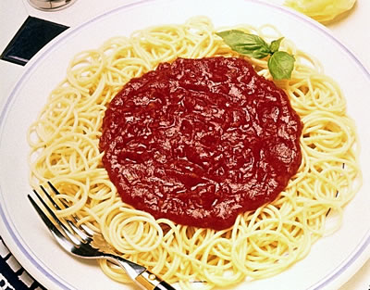
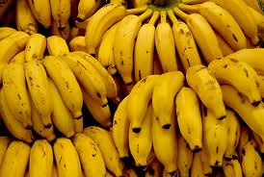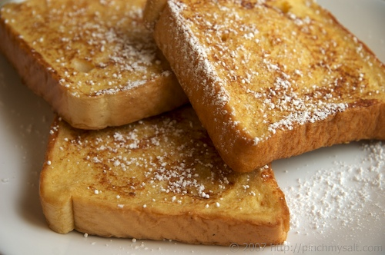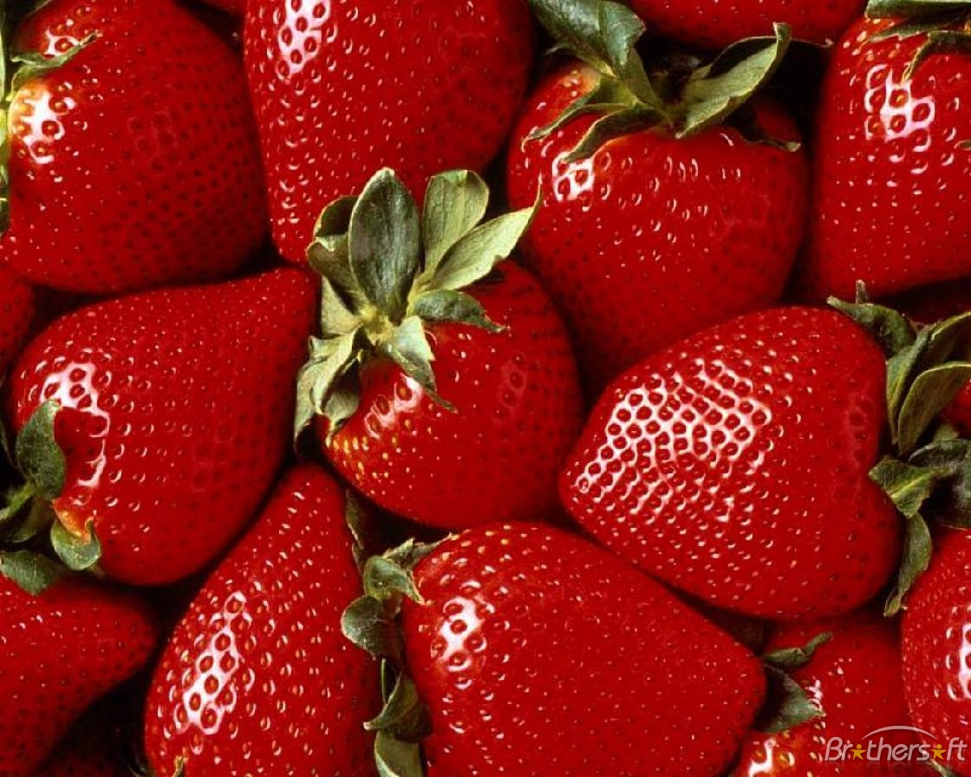

Drinks: Dr. Pepper, Root beer, Sprite, Water, Pepsi, Coca Cola,

Menu

Italian Chinese Around the world
- Spaghetti and meatballs $5.00 1. Pin wheels $1.00 1. Orange $0.50
- Pizza $3.99 (whole pizza) 2. Rice $1.00 2. Lime $0.50
- Turkey Sandwich $1.99 3. Squash $ 2.00 3. Grape Fruit $1.00
- Toast $0.50 4. Egg rolls $0.50 4. Bananas $ 0.50
- Cinnimonrolls $1.99 5. Shrimp $ 1.00
- Shiskabob’s $2.00
- Lasagna $2.99

