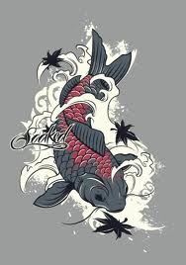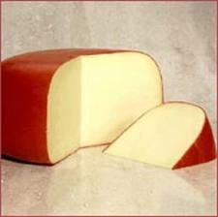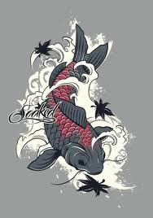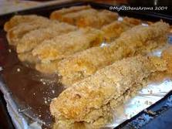

The perfect experience for any couple in our beautiful sunroom. And for your huge families we have a huge family table , and while you wait we will serve you gouda and sharp cheddar.

A quality restaurant from South Korea .We have lots of different foods such as tofu , fish , soup and lots more!

## Silver Fish

Come to the Silver Fish today don’t wait till Sunday come everyday. Come with this add and get 50% off your meal.

Only usable till 4/6/11

Vegans come on we have tofu fish sticks to concur your hunger at $4.50. We also have fish soup high in protein and low carbohydrates $5.00.