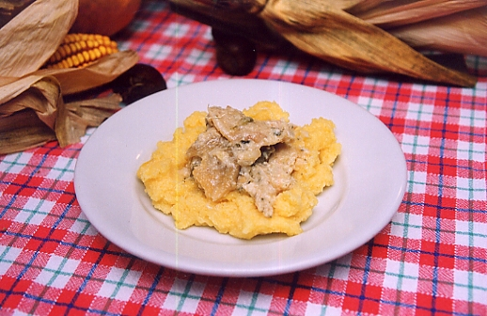[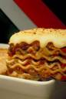](http://www.clipart.com/en/close-up?o=5070765&memlevel=A&a=a&q=Lasagna&k_mode=all&s=1&e=7&show=&c=&cid=&findincat=&g=&cc=&page=&k_exc=&pubid=)[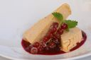](http://www.clipart.com/en/close-up?o=2835870&memlevel=A&a=a&q=Cheesecake&k_mode=all&s=19&e=36&show=&c=&cid=&findincat=&g=&cc=&page=2&k_exc=&pubid=)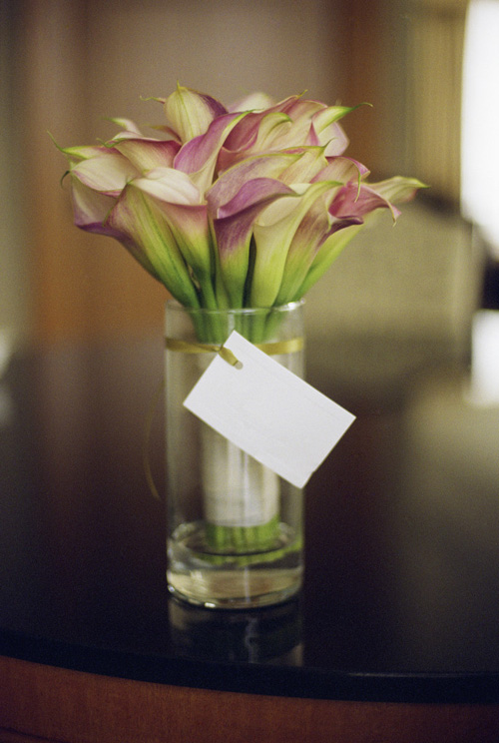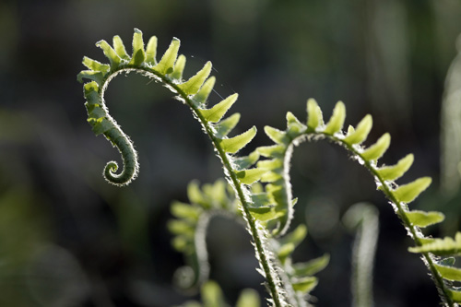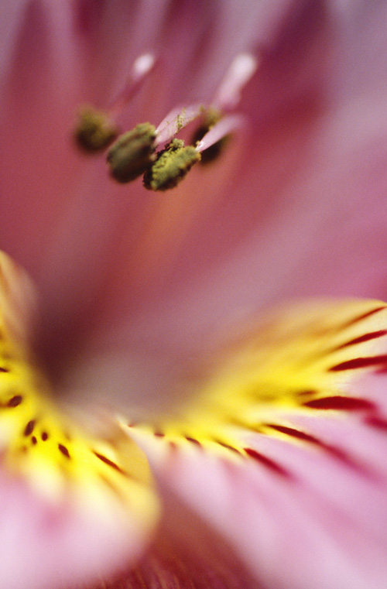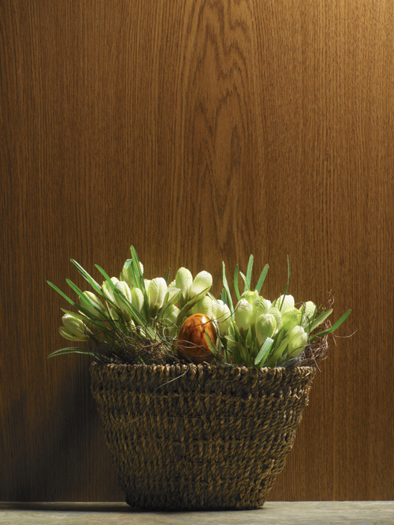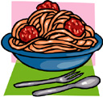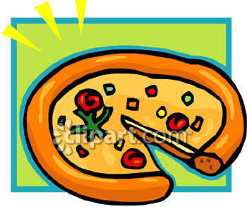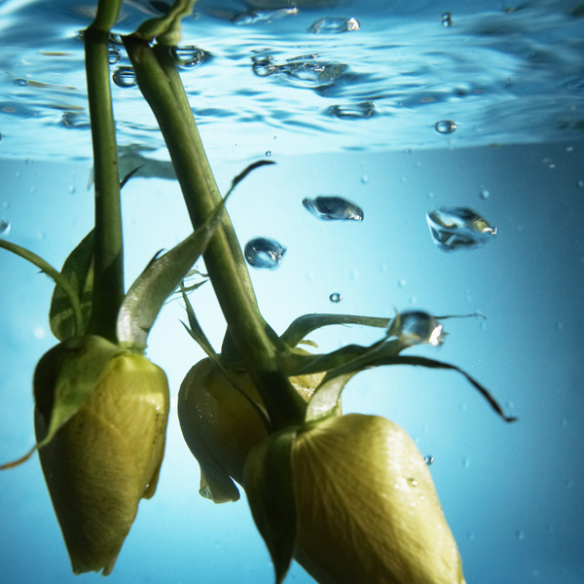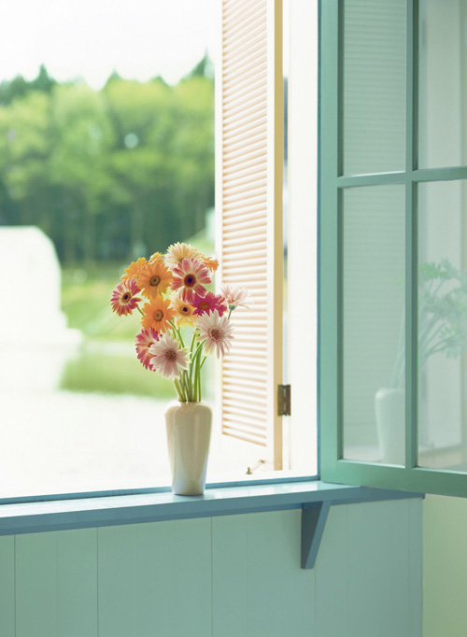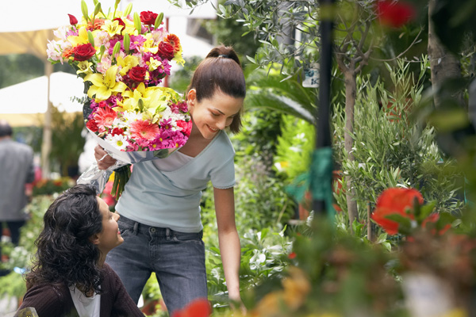

MAIN DISHES

4 Cheese Lasagna $4.00

Spaghetti with Meat Sauce $3.50

Chef Salad $6.00

Chicken Alfredo $10.00

SIDES

Bread Sticks

Mozzarella Cheese

Marinara Sauce

Small Caesar Salad

ALL SIDES ARE $1.00

We are happy to have you. Italianos is an Italian restaurant. We serve many Italian foods here at Italianos; we serve things from Chicken Alfredo to Fried Ice Cream. We hope you enjoy dining here.

Welcome to Italianos

Iyiuyuiuyiuikhuihjihiouol gal. ghfghfgjhgjhjjhjkkillool;ppol;;l;lll,

KIDS MENU / DESERT MENU

Fried Ice Cream $3.00

(Chocolate, Vanilla, Mint Chip)

Raspberry Cheesecake $8.00

$2.00 per piece

Small Sundae $3.00

Milk Shake $3.00

Small Pizza $2.00

Spaghetti and Meatballs $3.00

Corndog $1.00

Macaroni and Cheese $2.00

**DRINKS**

**ALL FOUNTAIN DRINKS ARE $1.00**

Dr. Pepper

Diet Dr. Pepper

Coke Cola

Sprite

Orange Soda